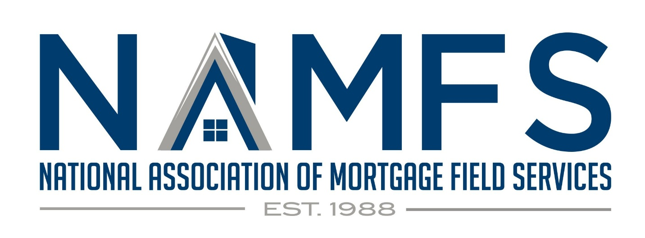White Paper: The Need for Increased Compensation for Winterization Services in the Mortgage Field Services Industry

Winterization services in the Mortgage Field Services (MFS) industry exposes service providers to significant increases in risk and liability. The winterization process, which involves preparing vacant properties to withstand cold weather, is crucial to preventing costly damage such as burst pipes and structural degradation. However, despite the critical nature of these services, compensation for winterization tasks has not kept pace with the heightened responsibilities, risks, and costs associated with them.
This white paper aims to demonstrate the need for higher payment for winterization services, considering increased operational costs, liability exposure, and the complexity of the process. By compensating service providers more fairly, mortgage companies can ensure higher quality work, reduced legal exposure, and better protection of their assets.
Introduction
Winterization in the MFS industry refers to the process of preparing a vacant property for freezing temperatures. It includes draining plumbing systems, applying antifreeze, insulating pipes, and securing windows and doors. These actions are essential to prevent property damage and maintain the value of vacant homes. However, the compensation models currently in place do not reflect the complexity or increased liability associated with these tasks. Additionally, the allowables reimbursement in the MFS industry is lower than the cost associated with winterizing a single hull boat ($300 average) or a standard RV ($200 average).
Key Challenges in Winterization
- Increased Risk and Liability: Winterization services inherently carry significant risks due to the following factors:
  - Property Damage: Even with proper procedures, there is always a risk that freezing temperatures will cause pipes to burst or damage structures. If the service provider is held responsible for subsequent damage, the liability can be financially devastating.
  - Documentation and Compliance: The level of documentation required by clients has increased to ensure accountability, often requiring photos, paperwork, and proof of compliance with local ordinances. Incorrect or incomplete documentation can lead to penalties, further adding to the financial burden on service providers.
  - Insurance Premiums: As the risk profile for MFS providers increases, so do insurance premiums. In particular, insurance (general liability along with errors and omissions (E&O) costs have risen greater than 40% since 2020, yet compensation for winterization services has remained stagnant.
Unpredictable Costs
- Material Costs: The cost of materials needed for winterization (such as antifreeze, insulation, and seals) has increased significantly due to inflation and supply chain disruptions.
- Labor Intensity: Winterizing a property requires specialized knowledge and skilled labor. Finding and retaining qualified workers for such technical tasks increases payroll expenses. Additionally the size of the property impacts the time necessary to complete. The average square footage of properties has more than doubled since the 1990s with additional bathrooms and various methods (zonal heating, in- floor, on-demand water heaters) further adding to the time to complete this service
- Travel Costs: MFS providers often service rural or distant properties, leading to increased fuel costs and vehicle wear-and-tear. The need for additional site visits (e.g., post-winterization inspections) further compounds these costs.
Intensifying & Unpredictable Weather Patterns
As global climate patterns shift, more regions are experiencing severe winter conditions that they were previously unprepared for. This leads to higher demand for winterization services and increased complexity in properties that are not designed for freezing temperatures. Properties in warmer climates may require additional retrofitting or enhanced winterization efforts, which further increases the cost and risk for service providers.
Industry Data and Case Studies
Industry data shows that the costs associated with improper or incomplete winterization can be staggering:
Pipe Burst Repairs: A single burst pipe can cost between $5,000 and $70,000 for repairs, depending on the size of the property. Service providers who underperform due to tight margins may fail to fully prevent such disasters.
Increased Insurance Claims: According to industry statistics, MFS companies have seen a rise in insurance claims tied to winterization failures. These claims not only increase costs for the providers but also strain relationships with clients.
For example, a NAMFS member company in the Mid-Atlantic documented a 75% increase in costs related to improper winterizations over a five-year period, largely due to service providers working with outdated pricing models that no longer reflect the real costs of doing business.
The Case for Increased Compensation
- Aligning Payment with Liability: Current compensation models do not account for the significant legal and financial exposure service providers face. Winterizations should see an immediate increase in compensation as defined in the NAMFS Pricing Initiative which details utilization of cost estimator and time/material models. This Initiative specifically addresses the time, expertise, and liability involved. Increased payments would allow service providers to invest in better insurance, more reliable materials, and highly trained workers, reducing the likelihood of costly errors and claims.
- Quality Assurance and Client Satisfaction: Adequate compensation would ensure that winterization service providers can perform their work to the highest standards. By paying for expertise and professionalism, mortgage servicers would protect their properties and reduce their own exposure to loss. This could also minimize costly follow-up work and repairs, which in turn improves client satisfaction and reduces disputes.
- Sustainable Business Practices: Without appropriate compensation, many smaller MFS providers are unable to sustain their businesses. Rising costs and stagnant fees are leading to high turnover in the industry, creating a shortage of reliable contractors. By increasing winterization payments, mortgage companies would help stabilize the MFS industry, ensuring the availability of skilled professionals in the future.
Proposed Payment Adjustments
- Base Payment Increase: Review the NAMFS Pricing Initiative as a guidance for determining the increase to existing allowable compensation for winterization services, which accounts for inflation and the rise in material and labor costs.
- Risk-Based Incentives: Additional payments for properties located in extreme weather regions, or where the complexity of winterization is greater (e.g., large, older, or high-risk properties).
- Cost-of-Living Adjustments: Annual reviews of payment models to adjust for changes in material costs, labor rates, and other factors.
- Liability Offsets: Investors, Insurers, and/or Mortgage servicers should consider offering additional payments to cover higher insurance premiums or provide indemnity clauses for service providers facing unreasonable liability exposure.
Conclusion
Winterization is an essential service in the mortgage field industry, protecting properties from severe weather conditions and preventing costly damage. However, service providers face significant risk and rising costs that current compensation models fail to address. By increasing payments for winterization services, mortgage companies will not only protect their assets but also ensure a more stable, reliable workforce, reduce liability, and improve the quality of service provided.
The Mortgage Field Services industry must act now to align compensation with the risks and responsibilities shouldered by winterization service providers. Doing so will ensure long-term sustainability for service providers and better outcomes for all stakeholders involved.

