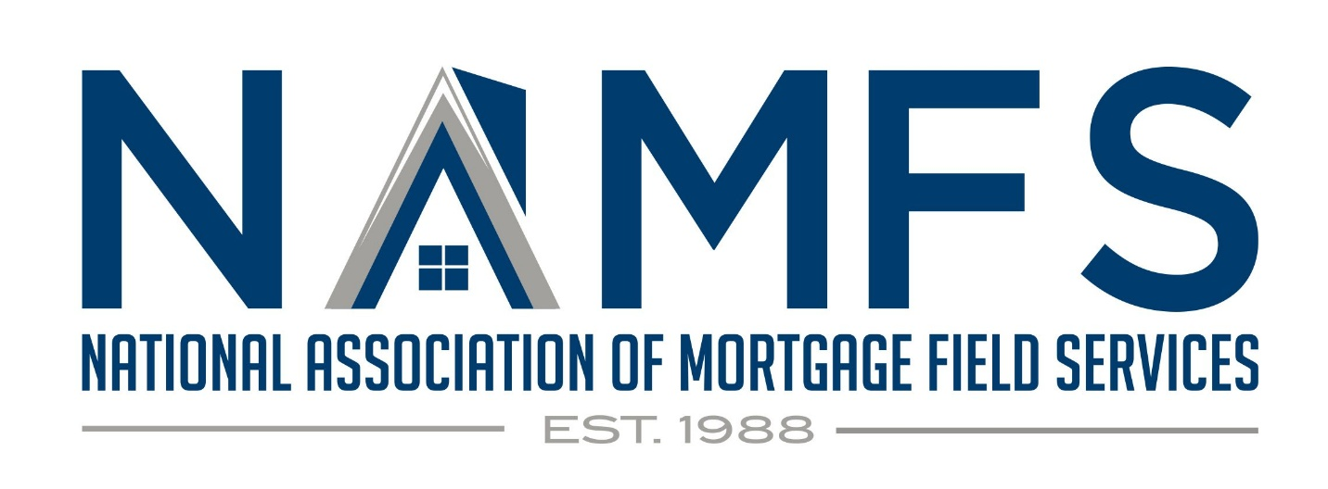
White Paper: Justifying Increased Pricing for Property Condition Reports and Bids in the Mortgage Field Services Industry
The Mortgage Field Services (MFS) industry plays a critical role in maintaining the value of properties for mortgage holders, particularly during foreclosure or vacant property situations. One of the most important tasks in this process is the Property Condition Report (PCR), which provides a thorough assessment of a property’s current state. However, the pricing model for PCRs has not kept pace with the complexity, scope, and liability involved in performing these assessments.
Additionally, the industry needs to address the growing demands for bids related to conveyance, safety issues, and property damages. These bids require technical expertise, time, and documentation that go largely uncompensated. Finally, recurring property visits—for both PCRs and bid verification—are a routine part of property maintenance, yet providers do not receive payment for these ongoing services.
This white paper outlines why these services deserve increased pricing and compensation, reflecting the actual cost, risk, and effort required to perform them effectively and sustainably.
Introduction
Mortgage servicers depend on the MFS industry to protect their interests in vacant or distressed properties. Accurate and timely Property Condition Reports (PCRs) help mitigate risk and ensure properties remain in good condition until they can be sold or transferred. However, the industry is facing significant pressure due to the inadequacy of current compensation models for these reports. Additionally, property preservation contractors often spend time generating bids for conveyance, safety concerns, and damages without receiving adequate or any payment. These services are critical to safeguarding properties, but their uncompensated nature puts undue strain on contractors, reducing the quality of work and risking delayed actions on safety hazards.
1. Key Challenges in the Current Compensation Model
Complexity of Property Condition Reports (PCRs)
PCRs are much more than a simple checklist. They require:
Extensive Documentation & Photo Verification: Contractors must photograph and document the entire property, inside and out, including assessing hidden or potential damage, ensuring safety compliance, and verifying the condition of mechanical systems, windows, doors, and the roof. This requires a skilled professional with an eye for detail.
Local Ordinance Knowledge: Each property is subject to specific local and state regulations. Ensuring that the property complies with these laws demands local knowledge, time, and research.
Liability: A poorly conducted PCR can expose the contractor to significant liability. If a critical issue is missed or inaccurately reported, contractors can face costly legal claims, and mortgage holders can lose tens of thousands of dollars in repairs or property devaluation.
2. Unpaid Bids for Conveyance, Safety, and Damages
Conveyance: When preparing properties for conveyance, MFS providers are expected to inspect the property, create itemized bids for any necessary repairs or compliance tasks, and submit them to mortgage servicers. This can involve significant work, from inspecting code violations to assessing the cost of structural repairs.
Safety Issues: For properties that pose safety risks, bids are critical in detailing how to remedy issues like electrical hazards, mold, asbestos, or dangerous structural conditions. These bids require the contractor’s expertise to estimate costs, secure contractor services, and ensure compliance with local laws.
Damages: Identifying and assessing property damage requires thorough investigation and understanding of repair costs. Providers must create itemized bids that are detailed enough for the mortgage company to approve, which is a time-consuming process often conducted without compensation.
3. Recurring Property Visits
For many properties, PCRs or safety inspections are required multiple times during the property’s lifecycle. Each visit requires:
Time and Travel Costs: Recurring inspections mean contractors are constantly traveling to remote properties, adding to fuel and vehicle maintenance costs.
Liability and Risk: Each visit opens contractors to additional liability. A missed problem in one visit may lead to a claim of negligence, even if the issue was not obvious at the time of inspection.
Administrative Burden: Contractors must not only visit properties but also complete additional documentation, submit updated bids, and communicate with mortgage servicers on every visit, further increasing the time and effort involved.
The Case for Increased Compensation
1. Increased Complexity and Risk in PCRs
PCRs have evolved into comprehensive reports that require significantly more work, time, and expertise than ever before. There is also the requirement for photo documentation, at a minimum, along with necessary documentation and compliance checks. This specifically involves:
Specialized Knowledge: Contractors must be familiar with a variety of local regulations, potential hazards, and repair protocols.
Liability Exposure: Incomplete or inaccurate reports can lead to legal claims, for which the contractor is responsible. Given the increased complexity, the risk of errors rises, along with the cost of insurance and legal protection.
Resource Intensity: Each PCR now requires several hours of work to ensure that all potential issues are covered. The amount of travel time, report writing, and follow-up required is disproportionate to the payment currently offered.
2. Fair Compensation for Bids
Creating bids is not a simple or risk-free task:
Expertise Required: Contractors need in-depth knowledge of construction, safety codes, and market prices for materials and labor. Developing accurate bids takes time and skill, especially when those bids are used to prevent further damage or ensure safety.
Opportunity Cost: Contractors often provide these bids without compensation, while spending time that could otherwise be spent performing billable work. This practice is unsustainable and deters skilled contractors from remaining in the industry.
Safety Concerns: Unpaid bids for safety-related issues can lead to delayed repairs or ignored hazards. Contractors are less likely to submit bids for urgent repairs if they know the process is lengthy and unpaid.
3. Compensation for Recurring Visits
Ongoing Workload: Each visit to a property requires travel, documentation, and follow-up with the mortgage servicer. These repeat visits often require contractors to return to the same property multiple times for updates, repairs, or further inspections.
Increased Travel Costs: With rising fuel prices and the need for repeat travel to often remote locations, contractors are bearing additional out-of-pocket expenses that are not reimbursed in the current compensation model.
Value to Investor/Insurers/Servicers: Regular property visits ensure properties are well-maintained, help prevent larger damages from developing, and provide early detection of potential issues. Fair compensation for these visits ensures contractors can maintain the quality and frequency of service that mortgage companies depend on.
Proposed Adjustments to Compensation
1. Increased Base Payment for PCRs: PCRs should see an immediate increase in compensation as defined in the NAMFS Pricing Initiative which details utilization of cost estimator and time/material models. This Initiative specifically addresses the time, expertise, and liability involved. This would allow contractors to invest in the training, insurance, and technology necessary to deliver accurate and detailed reports.
2. Compensation for Bids: Mortgage servicers should compensate contractors for the time and expertise involved in generating bids, particularly those related to conveyance, safety, and damages. A flat fee for each property bid could incentivize higher-quality work and address the lost time for providing the necessary bid and documentation.
3. Payment for Recurring Visits: Each return visit to a property should include compensation, recognizing the additional time, travel, and liability involved. Once again, the NAMFS Pricing Initiative provided details utilizing the cost estimator and the time/material models for these recurring visits. This could be adjusted based on the complexity of the tasks required during each visit.
4. Additional Compensation for High-Risk Properties: Properties with high damage potential or located in areas requiring extensive travel or specialized knowledge should qualify for a premium payment structure. This reflects the increased risk and difficulty in managing such properties.
Conclusion
The Mortgage Field Services industry is facing unprecedented challenges as it grapples with the increasing complexity of property management, growing liability risks, and rising operational costs. Property Condition Reports (PCRs) are essential to safeguarding mortgage holders’ assets, yet contractors are often undercompensated for the work they perform. Similarly, the bidding process for conveyance, safety repairs, and damage assessments is time-intensive and requires specialized expertise that is not being adequately reimbursed. Recurring visits, which are critical to maintaining property condition and ensuring safety, also go underpaid, despite their importance to the process.
By increasing payments for these services, mortgage servicers can ensure higher-quality work, reduced liability, and more sustainable business practices within the MFS industry. Investing in fair compensation for contractors ultimately benefits all parties, ensuring properties remain well-maintained and valuable.

